Contents

[2 America’s China Bashing: A compendium of Junk Economics 1](#_Toc274668443)

[2.1 Responses (2) to America’s China Bashing: A Compendium of Junk Economics 7](#_Toc274668444)

[3 The Roving Cavaliers of Credit 8](#_Toc274668445)

[3.1 The conventional model: the “Money Multiplier” 9](#_Toc274668446)

[3.1.1 The Data versus the Money Multiplier Model 11](#_Toc274668447)

[3.2 How to be a “Cavalier of Credit” 21](#_Toc274668448)

[3.2.1 We Live in a Credit-Money, not a Fiat-Money System 21](#_Toc274668449)

[3.2.2 Fundamentals of a Pure Credit Economy 22](#_Toc274668450)

[3.2.3 A Toy Pure Credit Economy 28](#_Toc274668451)

[3.2.4 A More Realistic Toy Pure Credit Economy, and Its Implications 32](#_Toc274668452)

[3.3 Conclusion 41](#_Toc274668453)

[3.4 Debtwatch Statistics February 2009 42](#_Toc274668454)

[3.5 References 45](#_Toc274668455)

[3.6 Responses (309 of them) 48](#_Toc274668456)

# America’s China Bashing: A compendium of Junk Economics

[ The original paper, which stimulated my below comments, was at <http://michael-hudson.com/2010/09/america%E2%80%99s-china-bashing-a-compendium-of-junk-economics/> in October, 2010. –FNC]

*September 29, 2010*

By [Michael Hudson](http://michael-hudson.com/author/Michael%20Hudsom/)

It is traditional for politicians to blame foreigners for problems that their own policies have caused. And in today’s zero-sum economies, it seems that if America is losing leadership position, other nations must be the beneficiaries. Inasmuch as China has avoided the financial overhead that has painted other economies into a corner, nationalistic U.S. politicians and journalists are blaming it for America’s declining economic power.

I realize that balance-of-payments accounting and international trade theory are arcane topics, but I promise that by the time you finish this article, you will understand more than 99% of U.S. economists and diplomats striking this self-righteous pose.

**The dollar’s double standard gives America an international free ride**  
For over a century, central banks have managed exchange rates by raising or lowering the interest rate. Countries running trade and payments deficits raise rates to attract foreign funds. The IMF also directs them to impose domestic austerity programs that reduce asset prices for their real estate, stocks and bonds, making them prone to foreign buyouts. Vulture investors and speculators usually have a field day, as they did in the Asian crisis of 1997.

Conversely, low interest rates lead bankers and speculators to seek higher returns abroad, borrowing domestic currency to buy foreign securities or make foreign loans. This capital outflow lowers the exchange rate.

There is a major exception, of course: the United States. Despite running the world’s largest balance-of-payments deficit and also the largest domestic government budget deficit, it has the world’s lowest interest rates and easiest credit. The Federal Reserve has depressed the dollar’s exchange rate by providing nearly free credit to banks at only 0.25% interest. This “quantitative easing” (making it easier to borrow more) aims at preventing U.S. real estate, stocks and bonds from falling further in price. The idea is to save banks from more defaults as the economy slips deeper into negative equity territory. A byproduct of this easy credit is to lower the dollar’s exchange rate – presumably helping U.S. exporters while forcing foreign producers either to raise the dollar price of their goods they sell here or absorb a currency loss.

This policy makes the dollar a managed currency. Low U.S. interest rates and easy credit spur investors to lend abroad or buy foreign assets yielding more than 1%. This dollar outflow forces other countries to protect their currencies from being forced up. So their central banks do not throw the excess dollars they receive onto the “free market,” but keep them in dollar form by buying U.S. Government bonds. So the “Chinese savings,” “yen savings” and “Euro savings” that are spent on U.S. Treasury securities (and earlier, on Fannie Mae bonds to earn a bit more) are not really what Chinese people save in their local yuan, or what Japanese or Europeans save. The money used to buy U.S. Government securities consists of the excess dollars that the American military, American investors and American consumers spend abroad in excess of U.S. earning power. To pretend that these savings are “saved up” by foreigners (who save in their own currency, after all) is Junk Economics Error #1.

By lowering U.S. interest rates to near zero, the U.S. Federal Reserve is doing what the Bank of Japan did after its financial bubble burst in 1990, when it helped Japanese banks “earn their way out of negative equity” by providing cheap credit to obtain a markup by lending to speculators and arbitrageurs to buy foreign bonds paying higher rates. This came to be known as the “carry trade.” Arbitrageurs borrowed yen cheaply, and converted them into Euros, dollars, Icelandic kroner or other currencies paying a higher rate, pocketing the difference. The practice threw yen onto foreign-exchange market, weakening the exchange rate and hence helping Japanese automotive and electronics exporters.

This is the easy credit policy that the Fed is following today. U.S. banks borrow from the Federal Reserve at 0.25%, and lend to speculators at a markup of one or two percentage points. These speculators then look for companies, government bonds, corporate stocks and bonds and any other asset in a foreign currency that they believe may yield more than about 2% (or that are denominated in currencies that may raise in price against the dollar by more than 2% annually), hoping to pocket the difference.

Accusations that Japan, South Korea and Taiwan are “making their currencies cheaper” by recycling their dollar inflows into U.S. Treasury securities simply means that they are trying to maintain their currencies at a stable level. Even so, the yen’s exchange rate has risen as international borrowers pay off their carry-trade debts by re-converting the Euros, dollars and other currencies they borrowed in yen to play the arbitrage game. Paying back these foreign currency loans raises the yen’s price.

To prevent this from pricing Japanese exporters out of world markets, Japan’s central bank is trying to stabilize the yen/dollar exchange rate by recycling these payments into the purchase of U.S. Treasury securities – exactly what U.S. officials accuse China of doing. It is how most central banks throughout the world are responding to the global dollar glut. They are increasing their international reserves by the amount of surplus free credit” dollars that the U.S. payments deficit is pumping out.

To pretend that China is “manipulating its currency” by doing what central banks have done for over a century is **Junk Economics Error #2**. Back in the early 1970s, U.S. officials told OPEC governments that if they did not do this, it would be deemed an act of war.) This recycling of foreign balance-of-payments surpluses to finance the U.S. federal budget deficit (by buying Treasury securities) is the essence of the U.S. Treasury-bill standard since 1971.

**Every currency must be managed by recycling dollars to avoid distorted exchange rates**  
International currency speculation and investment is much larger than the volume of commodity trade. To pretend that exchange rates are determined mainly by international trade is Junk Economics Error #3. The typical currency bet lasts less than a minute, often being computer-driven by arbitrage swap models. This short-term financial fibrillation has dislodged exchange rates from purchasing-power parity or prices for export and imports.

The largest international payments imbalances thus have little to do with “market forces.” They are what economists call price-inelastic – money spent without regard for price. This is true above all for military spending and maintenance of America’s vast network of foreign bases and political maneuverings to control foreign countries. During the 1960s and ‘70s U.S. overseas military spending was so large that it represented the entire balance-of-payments deficit, as private sector trade and investment remained in balance. Escalation of America’s oil war in the Near East and Pipelinistan, and the hundreds of billions of dollars spent to prop up America-friendly regimes, is pouring dollars into foreign economies, where they end up in central banks – whose main option, as noted above, is to send them back to the United States in the form of purchases of U.S. Treasury bills.

None of this can be blamed on China. But any nation that succeeds economically is assumed to be doing so at America’s expense. It is as if other countries should sacrifice themselves to let American investors siphon off the entire surplus. This attitude is sweeping Congress, whose China bashing is reminiscent of the Japan-phobia of the late 1980s. This ended when the United States convinced the Bank of Japan to commit financial suicide by agreeing to the Plaza and Louvre Accords turning Japan into a bubble economy by raising the yen’s exchange rate after 1985 and then flooding the economy with credit. Tokyo was humorously referred to as “the 13th Federal Reserve district” for recycling its export earnings in U.S. Treasury bills, becoming the mainstay of the Reagan-Bush budget deficits that financed U.S. global military spending while quadrupling the public debt.

In today’s replay, U.S. strategists would not mind seeing China’s economy similarly untracked by letting global speculators bid up the renminbi’s exchange rate – by enough to let Wall Street speculators make hundreds of billions of dollars betting on the run-up. “Free capital markets” and “open financial markets” are euphemisms for setting the renminbi’s exchange rate by the pace of U.S. and European currency arbitrage and capital flight. The U.S. balance-of-payments outflow would increase rather than shrink, thanks to the ability of American banks to create nearly “free” credit on their keyboards to convert into Chinese or other currencies, gold or other speculative vehicles that look to rise against the dollar.

“In a world awash with excess savings, we don’t need China’s money,” writes Prof. Krugman. After all, “the Federal Reserve could and should buy up any bonds the Chinese sell.” It’s all just electronic credit. From reading such diatribes, or President Obama’s exchange with Prime Minister Wen Jiabao at the United Nations on September 23, one would not realize that Chinese savers have not sent a single yuan of their own money to the United States.

But that is the point! Mr. Krugman should have reminded his readers that the balance of payments is much more than the trade balance in today’s world swamped by financial speculation, and military spending. What China “invests” in the United States are the dollars thrown off by the U.S. balance-of-payments deficit. China would take a loss on the yuan-value of these dollars if it revalues its currency – as it has lost on the dollars it has turned over to Blackrock money mangers in the hope of making more than the minimal 1% available on U.S. Treasury securities.

China’s currency reserves – like those of its fellow BRIC members, Brazil, Russia and India (as well as OPEC) – are the dollars that U.S. investors and speculators, U.S. consumers, and the U.S. military are spending abroad. These dollars end up in foreign central banks as part of the global dollar glut.

Prof. Krugman describes China as “deliberately keeping its currency artificially weak. … feeding a huge trade surplus,” adding that “in a depressed world economy, any country running an artificial trade surplus is depriving other nations of much-needed sales and jobs.” In his reading the problem is not that America has let its economy be financialized, or that easy bank credit has bid up housing prices for American workers and loaded down their budgets with debt service that, by itself, exceeds the wage levels of most Asian workers. “An undervalued currency always promotes trade surpluses,” he explains.

But this is only true if trade is “price-elastic,” with other countries able to produce similar goods of their own at only marginally different prices. This is less and less the case as the United States and Europe de-industrialize and as their capital investment shrinks as a result of their expanding financial overhead ends in a wave of negative equity. To assume that higher exchange rates automatically reduce rather than increase a nation’s trade surplus is Junk Economics Error #4. It is a tenet of the free market fundamentalism that Prof. Krugman usually criticizes, except where China is concerned.

Chinese currency appreciation would let speculators and arbitrageurs make a killing on the currency shift. Its exports would cost more – but is it believable that America would rebuild its factories and re-employ the workforce that has been downsized and outsourced? To imagine that long-term investment responds to immediately is Junk Economics Error #5.

Prof. Krugman urges the United States to do what it “normally does” when other countries subsidize their exports: impose a tariff to offset the supposed subsidy. Congress is increasing the drumbeat of accusations that China is violating international trade rules by protecting itself from financialization. “Democrats in Congress are threatening to … slap huge tariffs on Chinese goods to undermine the advantages Beijing has enjoyed from a currency, the renminbi, that experts say is artificially weakened by 20 to 25 percent.” The aim is to make China “lift the strict controls on its currency, which keep Chinese exports competitive and more factory workers employed.” But such legislation is illegal under world trade rules.

This has not stopped the United States in the past, but the belief that it might succeed internationally is Junk Economics Error #6.

The cover story is that foreign exchange controls and purchases of U.S. securities keep the renminbi’s exchange rate low, artificially spurring its exports. The reality, of course, is that these controls protect China from U.S. banks creating free “keyboard credit” to buy out Chinese companies to buy out Chinese companies or load down its economy with loans to be paid off in renminbi whose value will rise against the deficit-ridden dollar. It’s the Wall Street arbitrage opportunity of the century that banks are pressing for, not the welfare of American workers.

The House Ways and Means Committee is demanding that China raise its exchange rate by 20%. This would enable speculators to put down 1% equity – say, $1 million to borrow $99 million and buy Chinese renminbi forward. The revaluation being demanded would produce a 2000% profit, turning the $100 million bet (and just $1 million “serious money”) into a $19 million windfall. It also would bankrupt Chinese exporters who had signed dollarized contracts with U.S. retailers.

The Internal Revenue Service treats such trading gains as “capital gains” and taxes them at only 15%, much less than the tax rate on earned income that wage-earners must pay. The Brazilian real has risen by about 25 per cent against the dollar since January 2009. Last week, Brazil’s state oil company, Petrobras, issued $67 billion in shares to exploit the nation’s new oil discoveries. Foreigners have been swamping Brazil’s central bank with a reported $1 billion per day for the past two weeks – about 10 times its daily average in recent months – but this was largely to absorb money entering the country to take part in last week’s issue by the national oil company.

This is a compendium of the kind of propaganda Americans are being subjected to these days. There is little acknowledgement that the United States is as guilty of “managing the dollar” by its policy of quantitative easing that depresses the exchange rate below what would be normal for any other economy suffering so gigantic and chronic payments deficits. It is the United States that is out of line with every other economy.

What makes this situation inherently unfair – and hence presumably temporary – is that while the Washington Consensus directs other countries to impose austerity plans, raise their taxes on consumers and cut vital spending, the Bush-Obama administration sanctimoniously blames China, not the U.S. financial system or post-Cold War military expansionism.

High U.S. labor costs are blamed. The usual picture drawn in the media is a travesty of workers are over-consuming and irresponsibly “living on credit.” Yet average wage levels have not risen for over thirty years, since 1979, and disposable personal income has been squeezed by rising housing costs and, above all, rising debt service and a tax shift off finance, industry and real estate (FIRE-sector) wealth onto labor. Largely responsible for the industrial trade balance moving into deficit (apart from food and arms exports) is the profile of blue-collar paycheck spending, inflated by payments to the FIRE sector.

Homeowners typically pay up to 40% of their income for mortgage debt service and other carrying charges, 15% for other debt (credit card interest and fees, auto loans, student loans, etc.), 11% for FICA wage withholding for Social Security and Medicare, and about 10 to 15% in other taxes (income and excise taxes). To cap matters, the financial burden of debt-leveraged real estate and consumption is aggravated by forced saving pension set-asides turned over to money managers for financial investment in these debt-leveraged financial instruments, and “financialized” wage withholding for Social Security. All these deductions are made before any money is left to buy food, clothing or other basic goods and services.

The U.S. and foreign economies alike are suffering from the idea that the way to get rich is by debt leveraging, not by staying out of debt. Under this condition the wealth of nations is whatever banks will lend – the “capitalization rate” of the national economic surplus. The banker’s dream is to lend against every source of revenue until it all ends up being pledged to pay interest. Corporate raiders are to use business cash flow to pay bankers and bondholders for the high-interest loans and junk bonds that provide them with takeover credit. Real estate’s rental value is to be devoted to carrying mortgage loans, while consumers pay their disposable personal income as interest (and increasingly, late fees) to the banks for credit cards, student loans and other debts.

But in the current New York Review of Books, Paul Krugman and Robin Wells actually blame China for Wall Street’s junk mortgage binge. Instead of pointing to criminal behavior by the banks, brokerage companies, bond rating agencies and deceptive underwriters, they try to take the financial sector off the hook: “Just as global imbalances – the savings glut created by surpluses in China and other countries – played an important part in creating the great real estate bubble, they have an important role in blocking recovery now that the bubble has burst.”

This sounds more like what one would hear from a Wall Street lobbyist than from a liberal Democrat. It is as if the real estate bubble didn’t stem from financial fraud, as my UMKC colleague Bill Black has explained – not from junk mortgages, NINJA loans or the Federal Reserve flooding the U.S. economy with credit to inflate the real estate bubbles and sending electronic dollars abroad to glut the global economy. It’s China’s fault for running large trade surpluses “at the rest of the world’s expense.” The authors do not explain how it helps China or other economies to let foreign investors buy their companies at a 20% return and pay in dollars that must be recycled to the U.S. Treasury earning just 1%. And Congress won’t let it buy U.S. companies.

This is the double standard at work.

Wall Street’s idea of “equilibrium” is that if only foreign countries would commit financial suicide along the lines that the United States is doing, then global equilibrium could be restored. But the most successful economies have

* kept their [FIRE-sector](http://en.wikipedia.org/wiki/FIRE_sector) costs of living and doing business within reasonable bounds, and
* are not remotely as debt-leveraged as the United States. German workers pay only about 20% of their income for housing – about half the rate of their U.S. counterparts.

German practice is not to make 100% mortgage loans, but to require down payments in the range of 30% such as still characterized the United States as recently as the 1980s.

The FIRE sector’s business plan has priced U.S. labor out of world markets. There seems little likelihood of making Chinese and German workers pay rents or mortgage interest as high as the United States? How can American economic strategists force them to raise the price of their college and university tuition so that they must take on the enormous student loans of the magnitude that Americans have to take on? How can they be persuaded to follow the high-cost U.S. practice of adding FICA-type wage withholding to the cost of living to save up pensions, Social Security and medical insurance in advance, instead of the pay-as-you-go basis that Germany quite rightly follows?

Such suggestions are a cover story for America’s own financial mismanagement. The U.S. idea for global equilibrium is to demand that that the rest of the world follow suit in adopting the short-term time frame typical of banks and hedge funds whose business plan is to make money purely from financial maneuvering, not long-term capital investment. Debt creation and the shift of economic planning to Wall Street and similar global financial centers is confused with “wealth creation,” as if it were what Adam Smith was talking about.

**A Modest Proposal**  
China is trying to help by voluntarily cutting back its rare earth exports. It has almost a monopoly, accounting for 97% of global trade in these 17 metallic elements. They are used in military and other high-technology applications, from guided missile steering systems and computer hard drives to hybrid electric automobile batteries. This has prompted China to recently cut back its exports to save its land from depletion (and also environmental pollution), and build up its own stockpile for future use.

I have a modest suggestion. Let China raise the price from a few dollars a pound to a few hundred dollars a pound. According to theory put forth by Mr. Krugman, the U.S. Congress and other China bashers, this should slow Chinese exports. It certainly would help promote world peace and demilitarization, because these rare earths are key elements in military technology. China should build up its national security stockpile of these key metallic minerals for the future – say, the next prospective five years of exportation.

It won’t, of course, because these exports are “price inelastic.” So are many of its other exports, and this category will rise as Chinese technology increases relative to that of financialized economies cutting back long-term investment, research and development in order to squeeze out returns more rapidly. That is the problem with financial management: its time frame is short-term.

As published in [Counterpunch](http://counterpunch.com/hudson09292010.html)

Tags: [China](http://michael-hudson.com/tag/china/), [Debt](http://michael-hudson.com/tag/debt/), [Krugman](http://michael-hudson.com/tag/krugman/)

## Responses (2) to America’s China Bashing: A Compendium of Junk Economics

[*You Have A Lot To Learn If You Think Anti-China Tariffs Will Accomplish Anything | Pitts Report*](http://www.pittsreport.com/2010/09/you-have-a-lot-to-learn-if-you-think-anti-china-tariffs-will-accomplish-anything/) on September 30, 2010 at 11:41 am

[...] Mike “Mish” Shedlock, Global Economic Trend Analysis | Sep. 30, 2010, 9:36 AM In America’s China Bashing: A Compendium of Junk Economics Michael Hudson takes Paul Krugman, protectionists, Congress, and other China bashers to task, [...]

1. [*Defending China’s Trade Policies; a "What If?" Thought Test | theworldnet.info*](http://theworldnet.info/2010/10/defending-chinas-trade-policies-a-what-if-thought-test/) on October 1, 2010 at 5:08 pm

[...] America’s China Bashing: A Compendium of Junk Economics Michael Hudson takes Paul Krugman, protectionists, Congress, and other China bashers to task, [...]

# The Roving Cavaliers of Credit

[ The original paper, [Steve Keen](http://en.wikipedia.org/wiki/Steve_Keen)’s DebtWatch No 31 February 2009: "The Roving Cavaliers of Credit", which stimulated my below comments, was at <http://www.debtdeflation.com/blogs/2009/01/31/therovingcavaliersofcredit/> in October, 2010. –FNC]

[See also Steve Keen’s update of this material at [Deleveraging with a twist](http://www.debtdeflation.com/blogs/2010/09/20/deleveraging-with-a-twist/) Sept 20, 2010. –FNC]

Published in January 31st, 2009

Posted by [Steve Keen](http://www.debtdeflation.com/blogs/author/admin/) in [Debtwatch](http://www.debtdeflation.com/blogs/category/debtwatch/" \o "View all posts in Debtwatch)

“***Talk about centralisation!****The credit system, which has its focus in the so-called national banks and the big money-lenders and usurers surrounding them, constitutes enormous centralisation, and gives this class of parasites the fabulous power, not only to periodically despoil industrial capitalists, but also to interfere in actual production in a most dangerous manner— and this gang knows nothing about production and has nothing to do with it.*” [[1]](http://www.debtdeflation.com/blogs/2009/01/31/therovingcavaliersofcredit/#_ftn1)

Ten years ago, a quote from Marx would have one deemed a socialist, and dismissed from polite debate. Today, such a quote can (and [did](http://business.smh.com.au/business/investors-shortchanged-20090123-7ob3.html?page=-1), along with [Charlie’s photo](http://images.smh.com.au/2009/01/23/358206/420KarlMarx-420x0.jpg)) appear in a feature in the [Sydney Morning Herald](http://www.smh.com.au/)—and not a few people would have been nodding their heads at how Marx got it right on bankers.

He got it wrong on some other issues,[[2]](http://www.debtdeflation.com/blogs/2009/01/31/therovingcavaliersofcredit/" \l "_ftn2)[[1]](#footnote-1) but his analysis of money and credit, and how the credit system can bring an otherwise well-functioning market economy to its knees, was spot on. His observations on the financial crisis of 1857 still ring true today:

“*A high rate of interest can also indicate, as it did in 1857, that the country is undermined by the****roving cavaliers of credit****who can afford to pay a high interest because they pay it out of other people’s pockets (whereby, however, they help to determine the rate of interest for all), and****meanwhile they live in grand style on anticipated profits****.*

*Simultaneously, precisely this can incidentally provide a very profitable business for manufacturers and others.****Returns become wholly deceptive as a result of the loan system****…*”[[1]](http://www.debtdeflation.com/blogs/2009/01/31/therovingcavaliersofcredit/#_ftn1)

One and a half centuries after Marx falsely predicted the demise of capitalism, the people most likely to bring it about are not working class revolutionaries, but the “Roving Cavaliers of Credit”, against whom Marx quite justly railed.

This month’s Debtwatch is dedicated to analysing how these Cavaliers actually “make” money and debt—something they think they understand, but in reality, they don’t. A sound model of how money and debt are created makes it obvious that we should never have fallen for the insane notion that the financial system should be self-regulating. All that did was give the Cavaliers a licence to run amok, with the consequences [augmented manyfold by computers – FNC] we are now experiencing yet again—150 years after Marx described the crisis that led him to write Das Kapital.

## The conventional model: the “Money Multiplier”

Every macroeconomics textbook has an explanation of how credit money is created by the system of fractional banking that goes something like this:

* Banks are required to retain a certain percentage of any deposit as a reserve, known as the “reserve requirement”; for simplicity, let’s say this fraction is 10%.
* When customer Sue deposits say 100 newly printed government $10 notes at her bank, it is then obliged to hang on to ten of them—or $100—but it is allowed to lend out the rest.
* The bank then lends $900 to its customer Fred, who then deposits it in his bank—which is now required to hang on to 9 of the bills—or $90—and can lend out the rest. It then lends $810 to its customer Kim.
* Kim then deposits this $810 in her bank. It keeps $81 of the deposit, and lends the remaining $729 to its customer Kevin.
* And on this iterative process goes.
* Over time, a total of $10,000 in money is created—consisting of the original $1,000 injection of government money plus $9,000 in credit money—as well as $9,000 in total debts. The following table illustrates this, on the assumption that the time lag between a bank receiving a new deposit, making a loan, and the recipient of the loan depositing them in other banks is a mere one week.

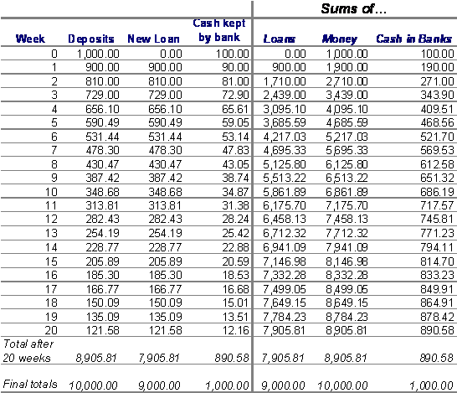

This model of how banks create credit is simple, easy to understand (this version omits the fact that the public holds some of the cash in its own pockets rather than depositing it all in the banks; this detail is easily catered for and is part of the standard model taught to economists),… and completely inadequate as an explanation of the actual data on money and debt.

### The Data versus the Money Multiplier Model

Two hypotheses about the nature of money can be derived from the money multiplier model:

1. The creation of credit money should happen after the creation of government money. In the model, the banking system can’t create credit until it receives new deposits from the public (that in turn originate from the government) and therefore finds itself with excess reserves that it can lend out. Since the lending, depositing and relending process takes time, there should be a substantial time lag between an injection of new government-created money and the growth of credit money.

2. The amount of money in the economy should exceed the amount of debt, with the difference representing the government’s initial creation of money. In the example above, the total of all bank deposits tapers towards $10,000, the total of loans converges to $9,000, and the difference is $1,000, which is the amount of initial government money injected into the system. Therefore the ratio of Debt to Money should be less than one, and close to (1-Reserve Ratio): in the example above, D/M=0.9, which is 1 minus the reserve ratio of 10% or 0.1.

Both these hypotheses are strongly contradicted by the data.

Testing the first hypothesis takes some sophisticated data analysis, which was done by two leading neoclassical economists in 1990.[[3]](http://www.debtdeflation.com/blogs/2009/01/31/therovingcavaliersofcredit/#_ftn3) If the hypothesis were true, changes in M0 should precede changes in M2. The time pattern of the data should look like the graph below: an initial injection of government “fiat” money, followed by a gradual creation of a much larger amount of credit money:

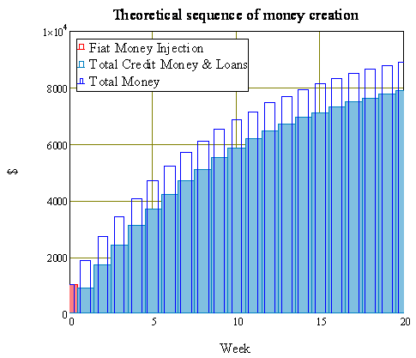

Their empirical conclusion was just the opposite: rather than fiat money being created first and credit money following with a lag, the sequence was reversed: credit money was created first, and fiat money was then created about a year later:

“*There is no evidence that either the monetary base or M1 leads the cycle, although some economists still believe this monetary myth. Both the monetary base and M1 series are generally procyclical and, if anything, the monetary base lags the cycle slightly. (p. 11)*

*The difference in the behavior of M1 and M2 suggests that the difference of these aggregates (M2 minus M1) should be considered… The difference of M2 – M1 leads the cycle by even more than M2, with the lead being about three quarters.*” (p. 12)

Thus rather than credit money being created with a lag after government money, the data shows that credit money is created first, up to a year before there are changes in base money. This contradicts the money multiplier model of how credit and debt are created: rather than fiat money being needed to “seed” the credit creation process, credit is created first and then after that, base money changes.

It doesn’t take sophisticated statistics to show that the second prediction is wrong—all you have to do is look at the ratio of private debt to money. The theoretical prediction has never been right—rather than the money stock exceeding debt, debt has always exceeded the money supply—and the degree of divergence has grown over time.(there are attenuating factors that might affect the prediction—the public hoarding cash should make the ratio less than shown here, while non-banks would make it larger—but the gap between prediction and reality is just too large for the theory to be taken seriously).

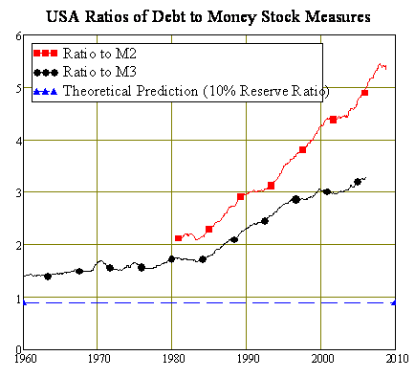

Academic economics responded to these empirical challenges to its accepted theory in the time-honoured way: it ignored them.

Well, the so-called “mainstream” did—the school of thought known as “Neoclassical economics”. A rival school of thought, known as Post Keynesian economics, took these problems seriously, and developed a different theory of how money is created that is more consistent with the data.

This first major paper on this approach, “The Endogenous Money Stock” by the non-orthodox economist Basil Moore, was published almost thirty years ago.[[4]](http://www.debtdeflation.com/blogs/2009/01/31/therovingcavaliersofcredit/#_ftn4) Basil’s essential point was quite simple. The standard money multiplier model’s assumption that banks wait passively for deposits before starting to lend is false. Rather than bankers sitting back passively, waiting for depositors to give them excess reserves that they can then on-lend,

“In the real world, banks extend credit, creating deposits in the process, and look for reserves later”.[[5]](http://www.debtdeflation.com/blogs/2009/01/31/therovingcavaliersofcredit/#_ftn5)

Thus loans come first—simultaneously creating deposits—and at a later stage the reserves are found. The main mechanism behind this are the “lines of credit” that major corporations have arranged with banks that enable them to expand their loans from whatever they are now up to a specified limit.

If a firm accesses its line of credit to, for example, buy a new piece of machinery, then its debt to the bank rises by the price of the machine, and the deposit account of the machine’s manufacturer rises by the same amount. If the bank that issued the line of credit was already at its own limit in terms of its reserve requirements, then it will borrow that amount, either from the Federal Reserve or from other sources.

If the entire banking system is at its reserve requirement limit, then the Federal Reserve has three choices:

* refuse to issue new reserves and cause a credit crunch;
* create new reserves; or
* relax the reserve ratio.

Since the main role of the Federal Reserve is to try to ensure the smooth functioning of the credit system, option one is out—so it either adds Base Money to the system, or relaxes the reserve requirements, or both.

Thus causation in money creation runs in the opposite direction to that of the money multiplier model: the credit money dog wags the fiat money tail. Both the actual level of money in the system, and the component of it that is created by the government, are controlled by the commercial system itself, and not by the Federal Reserve.

Central Banks around the world learnt this lesson the hard way in the 1970s and 1980s when they attempted to control the money supply, following neoclassical economist Milton Friedman’s theory of “monetarism” that blamed inflation on increases in the money supply. Friedman argued that Central Banks should keep the reserve requirement constant, and increase Base Money at about 5% per annum; this would, he asserted cause inflation to fall as people’s expectations adjusted, with only a minor (if any) impact on real economic activity.

Though inflation was ultimately suppressed by a severe recession, the monetarist experiment overall was an abject failure. Central Banks would set targets for the growth in the money supply and miss them completely—the money supply would grow two to three times faster than the targets they set.

Ultimately, Central Banks abandoned monetary targetting, and moved on to the modern approach of targetting the overnight interest rate as a way to control inflation.[[6]](http://www.debtdeflation.com/blogs/2009/01/31/therovingcavaliersofcredit/#_ftn6)[[2]](#footnote-2) Several Central Banks—including Australia’s RBA—completely abandoned the setting of reserve requirements. Others—such as America’s Federal Reserve—maintained them, but had such loopholes in them that they became basically irrelevant. Thus the US Federal Reserve sets a Required Reserve Ratio of 10%, but applies this only to deposits by individuals; banks have no reserve requirement at all for deposits by companies.[[7]](http://www.debtdeflation.com/blogs/2009/01/31/therovingcavaliersofcredit/#_ftn7)

However, neoclassical economic theory never caught up with either the data, or the actual practices of Central Banks—and Ben Bernanke, a leading neoclassical theoretician, and unabashed fan of Milton Friedman, is now in control of the Federal Reserve. He is therefore trying to resolve the financial crisis and prevent deflation in a neoclassical manner: by increasing the Base Money supply.

Give Bernanke credit for trying here: the rate at which he is increasing Base Money is unprecedented. Base Money doubled between 1994 and 2008; Bernanke has doubled it again in just the last 4 months.

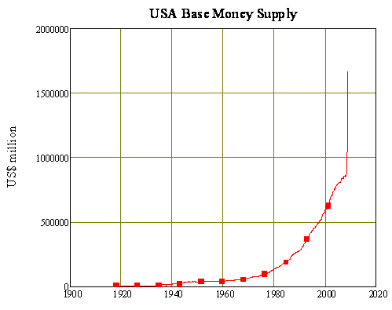

If the money multiplier model of money creation were correct, then ultimately this would lead to a dramatic growth in the money supply as an additional US$7 trillion of credit money was gradually created.

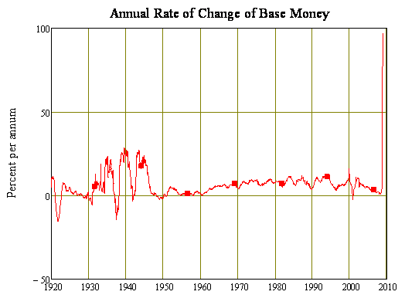

If neoclassical theory was correct, this increase in the money supply would cause a bout of inflation, which would end bring the current deflationary period to a halt, and we could all go back to “business as usual”. That is clearly what Bernanke is banking on:

“*The conclusion that deflation is always reversible****under a fiat money system*** *follows from basic economic reasoning. A little parable may prove useful: Today an ounce of gold sells for $300, more or less. Now suppose that a modern alchemist solves his subject’s oldest problem by finding a way to produce unlimited amounts of new gold at essentially no cost. Moreover, his invention is widely publicized and scientifically verified, and he announces his intention to begin massive production of gold within days.*

*What would happen to the price of gold? Presumably, the potentially unlimited supply of cheap gold would cause the market price of gold to plummet. Indeed, if the market for gold is to any degree efficient, the price of gold would collapse immediately after the announcement of the invention, before the alchemist had produced and marketed a single ounce of yellow metal.*

*Like gold, U.S. dollars have value only to the extent that they are strictly limited in supply. But the U.S. government has a technology, called a printing press (or, today, its electronic equivalent), that allows it to produce as many U.S. dollars as it wishes at essentially no cost.*

*By increasing the number of U.S. dollars in circulation, or even by credibly threatening to do so, the U.S. government can also reduce the value of a dollar in terms of goods and services, which is equivalent to raising the prices in dollars of those goods and services. We conclude that, under a paper-money system, a determined government can always generate higher spending and hence positive inflation…*

*If we do fall into deflation, however, we can take comfort that the logic of the printing press example must assert itself, and sufficient injections of money will ultimately always reverse a deflation.*” [[8]](http://www.debtdeflation.com/blogs/2009/01/31/therovingcavaliersofcredit/#_ftn8)

However, from the point of view of the empirical record, and the rival theory of endogenous money, **this will fail** on at least four fronts:

1. Banks won’t create more credit money as a result of the injections of Base Money. Instead, inactive reserves will rise;

2. Creating more credit money requires a matching increase in debt—even if the money multiplier model were correct, what would the odds be of the private sector taking on an additional US$7 trillion in debt in addition to the current US$42 trillion it already owes?;

3. Deflation will continue because the motive force behind it will still be there—distress selling by retailers and wholesalers who are desperately trying to avoid going bankrupt; and

4. The macroeconomic process of deleveraging will reduce real demand no matter what is done, as Microsoft CEO Steve Ballmer recently noted:  **“*We’re certainly in the midst of a once-in-a-lifetime set of economic conditions. The perspective I would bring is not one of recession. Rather, the economy is resetting to lower level of business and consumer spending based largely on the reduced leverage in economy*”.**[[9]](http://www.debtdeflation.com/blogs/2009/01/31/therovingcavaliersofcredit/#_ftn9)

The only way that Bernanke’s “printing press example” would work to cause inflation in our current debt-laden [economy?] would be if simply Zimbabwean levels of money were printed—so that fiat money could substantially repay outstanding debt and effectively supplant credit-based money.

Measured on this scale, Bernanke’s increase in Base Money goes from being heroic to **trivial**. Not only does the scale of credit-created money greatly exceed government-created money, but debt in turn greatly exceeds even the broadest measure of the money stock—the M3 series that the Fed some years ago decided to discontinue.

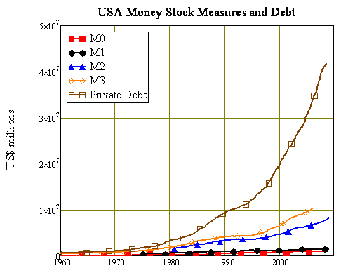

Bernanke’s expansion of M0 in the last four months of 2008 has merely reduced the **debt to M0 ratio** from 47:1 to 36:1 (the debt data is quarterly whole money stock data is monthly, so the fall in the ratio is more than shown here given the lag in reporting of debt).

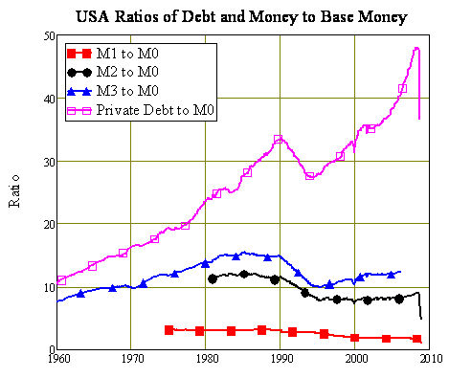

To make a serious dent in debt levels, and thus enable the increase in base money to affect the aggregate money stock and hence cause inflation, Bernanke would need to not merely double M0, but to increase it by a factor of, say, 25 from pre-intervention levels. That US$20 trillion truckload of greenbacks might enable Americans to repay, say, one quarter of outstanding debt with one half—thus reducing the debt to GDP ratio about 200% (roughly what it was during the DotCom bubble and, coincidentally, 1931)—and get back to some serious inflationary spending with the other [half] (of course, in the context of a seriously depreciating currency). But with anything less than that, his attempts to reflate the American economy will sink in **the ocean of debt created by America’s modern-day “Roving Cavaliers of Credit”**.

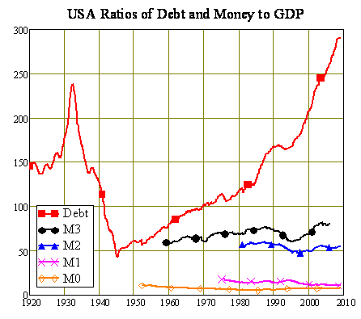

[Actually, a paper by the Fed itself, [Money, Reserves, and the Transmission of Monetary Policy -- Does the Money Multiplier Exist?](http://www.federalreserve.gov/pubs/feds/2010/201041/201041pap.pdf), indicates the same conclusion. -FNC]

## How to be a “Cavalier of Credit”

### We Live in a Credit-Money, not a Fiat-Money System

Note Bernanke’s assumption (highlighted above) in his argument that printing money would always ultimately cause inflation: “**under a fiat money system**“. The point made by endogenous money theorists is that **we don’t live in a fiat-money system, but in a credit-money system which has had a relatively small and subservient fiat money system tacked onto it.**

We are therefore **not in a “fractional reserve banking system”, but in a credit-money one, where the dynamics of money and debt are vastly different to those assumed by Bernanke and neoclassical economics** in general.[[10]](http://www.debtdeflation.com/blogs/2009/01/31/therovingcavaliersofcredit/#_ftn10)[[3]](#footnote-3)

Calling our current financial system a “fiat money” or “fractional reserve banking system” is akin to the blind man who classified an elephant as a snake, because he felt its trunk. We live in a credit money system with a fiat money subsystem that has some independence, but certainly doesn’t rule the monetary roost—far from it.

### Fundamentals of a Pure Credit Economy

The best place to start to analyse the monetary system is therefore to consider a model of a pure credit economy—a toy economy in which there is no government sector and no Central Bank whatsoever—and see how *that* model behaves.

The first issue in such a system is how does one become a bank?—or a “cavalier of credit” in Marx’s wonderfully evocative phrase? The answer was provided by the Italian non-orthodox economist Augusto Graziani: **a bank is a third party to all transactions, whose account-keeping between buyer and seller is regarded as finally settling all claims between them.**

Huh? What does that mean? To explain it, I’ll compare it with the manner in which we’ve been misled to thinking about the market economy by neoclassical economics.

It has deluded us into thinking of a market economy as being fundamentally a system of barter. Every transaction is seen as being two sided, and involving two commodities: Farmer Maria wants to sell pigs and buy copper pipe; Plumber Joe wants to sell copper pipe and buy pigs.

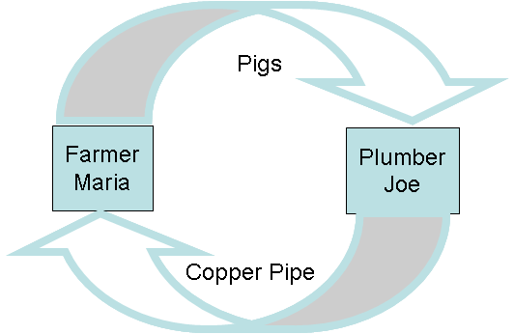

Money [ is not of the essence; it] simply eliminates the problem that it’s very hard for Plumber Joe to find Farmer Maria. Instead, they each sell their commodity for money, and then exchange that money for the commodity they really want. The picture appears more complicated—there are two markets introduced as well, with Farmer Maria selling pigs to the pig market in return for money, Plumber Joe doing the same thing in the copper market, and then armed with money from their sales, they go across to the other market and buy what they want. But it is still a lot easier than a plumber going out to try to find a pig farmer who wants copper pipes.

In this model of the economy, money is useful in that it replaces a very difficult search process with a system of markets. But fundamentally the system is no different to the barter model above: money is just a convenient “numeraire”, and anything at all could be used—even copper pipe or pigs—so long as all markets agreed to accept it. Gold tends to be the numeraire of choice because it doesn’t degrade, and paper money merely replaces gold as a more convenient form of numeraire.

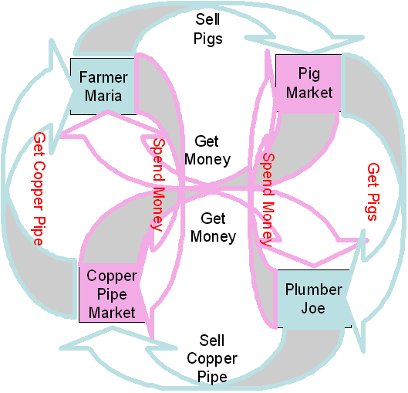

Importantly, in this model, **money is an asset to its holder, but a liability to no-one**. There is money, but no debt. [Gold money, for example.] The fractional banking model that is tacked onto this vision of bartering adds yet another market where depositors (savers) supply money at a price (the rate of interest), and lenders buy money for that price, and the interaction between supply and demand sets the price. Debt now exists, but in the model world total debt is less than the amount of money.

If this market produces too much money (which it can do in a fractional banking system because the government determines the supply of base money and the reserve requirement) then there can be inflation of the money prices of commodities. Equally if the money market suddenly contracts, then there can be deflation. It’s fairly easy to situate Bernanke’s dramatic increase in Base Money within this view of the world.

If only it were the world in which we live. Instead, we live in a **credit economy**, in which intrinsically useless pieces of paper—or even simple transfers of electronic records of numbers—are happily accepted in return for real, hard commodities. This in itself is not incompatible with a fractional banking model, but the empirical data tells us that credit money is created independently of fiat money: credit money rules the roost. So our fundamental understanding of a monetary economy should proceed from a model in which credit is intrinsic, and government money is tacked on later—and not the other way round.

Our starting point for analysing the economy should therefore be a “pure credit” economy, in which there are privately issued bank notes, but no government sector and no fiat money. Yet this has to be an economy in which intrinsically useless items are accepted as payment for intrinsically useful ones—you can’t eat a bank note, but you can eat a pig.

#### Necessary Conditions

So how can that be done without corrupting the entire system. Someone has to have the right to produce the bank notes; how can this system be the basis of exchange, without the person who has that right abusing it?

Graziani (and others in the “Circuitist” tradition) reasoned that this would only be possible if *the producer of bank notes—or the keeper of the electronic records of money—*  could **not** simply print them whenever he/she wanted a commodity, and go and buy that commodity with them. But at the same time, people involved in ordinary commerce had to accept the transfer of these intrinsically useless things in return for commodities.

“*Therefore for a system of credit money to work, three conditions had to be fulfilled:*

*In order for money to exist, three basic conditions must be met:*

*a) money has to be a token currency (otherwise it would give rise to barter and not to monetary exchanges);*

*b) money has to be accepted as a means of final settlement of the transaction (otherwise it would be credit and not money);*

*c) money must not grant privileges of seignorage to any agent making a payment.*”[[11]](http://www.debtdeflation.com/blogs/2009/01/31/therovingcavaliersofcredit/#_ftn11)

In Graziani’s words,

“*The only way to satisfy those three conditions is …****to have payments made by means of promises of a third agent****, the typical third agent being [a bank?] nowadays. When an agent makes a payment by means of a cheque, he satisfies his partner by the promise of the bank to pay the amount due.*

*Once the payment is made, no debt and credit relationships are left between the two agents. But one of them is now a creditor of the bank, while the second is a debtor of the same bank. This insures that, in spite of making final payments by means of paper money, agents are not granted any kind of privilege.*

*For this to be true,****any monetary payment must therefore be a triangular transaction, involving at least three agents, the payer, the payee, and the bank****.*” ( p. 3).

Thus in a credit economy, all transactions are involve one commodity [pigs, say.], and three parties: a seller, a buyer, and a bank whose transfer of money from the buyer’s account to the seller’s is accepted by them as finalising the sale of the commodity. [So in a **Pure-Credit\_Economy** a full transaction involves a Seller, a Buyer, a Bank, and a Commodity (pig) while in the neoclassical/Keynsian **Barter-plus-Commodity\_Money Economy** a full transaction involves two half-transactions: first a Seller, a monetary Commodity, and Commodity (pig) then first a buyer, a monetary Commodity, and Commodity (pig) Though Steve Keen doesn’t say so, it would appear that the essential bank is replaced by two essential commodity exchanges!!] So the actual pattern in any transaction in a credit money economy is as shown below:

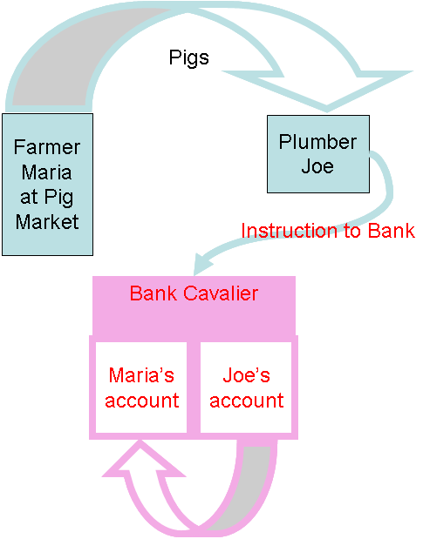

This makes banks and money an **essential** feature of a credit economy, not something that can be initially ignored and incorporated later, as neoclassical economics has attempted to do (unsuccessfully; one of the hardest things for a neoclassical mathematical modeller is to explain why money exists, apart from the search advantages noted above. Generally therefore their models omit money—and debt—completely).

It also defines what a bank is: it is a third party whose record-keeping is trusted by all parties as recording the transfers of credit money that effect sales of commodities. The bank makes a legitimate living by lending money to other agents—thus simultaneously creating loans and deposits—and charging a higher rate of interest on loans than on deposits.

Thus in a fundamental way, a bank is a bank because **it is trusted**. Of course, as we know from our current bitter experience, banks can damage that trust; but it remains the wellspring from which their existence arises.

This model helped [helps?] distinguish the realistic model of endogenous money from the unrealistic neoclassical vision of a barter economy. It also makes it possible to explain what a credit crunch is, and why it has such a devastating impact upon economic activity.

First, the basics: how does a pure credit economy work, and how is money created in one? (The rest of this post necessarily gets technical and is there for those who want detailed background. It reports new research into the dynamics of a credit economy. There’s nothing here anywhere near as poetic as Marx’s “Cavaliers of Credit”, but I hope it explains how a credit economy works, and how it can go badly wrong in a “credit crunch”)

How the Cavaliers “Make Money”

Several economists—notably Wicksell and Keynes—envisaged a “pure credit economy”. Keynes imagined a world in which “investment is proceeding at a steady rate”, in which case:

“*the finance (or the commitments to finance) required can be supplied from a revolving fund of a more or less constant amount, one entrepreneur having his finance replenished for the purpose of a projected investment as another exhausts his on paying for his completed investment.*” [[12]](http://www.debtdeflation.com/blogs/2009/01/31/therovingcavaliersofcredit/#_ftn12)

### A Toy Pure Credit Economy

This is the starting point to understanding a pure credit economy—and therefore to understanding our current economy and why it’s in a bind. Consider an economy with three sectors: firms that produce goods, banks that charge and pay interest, and households that supply workers. Firms are the only entities that borrow, and the banking sector gave loans at some stage in the past to start production. Firms hired workers with this money (and bought inputs from each other), enabling production, and ultimately the economy settled down to a constant turnover of money and goods (as yet there is no technological change, population growth, or wage bargaining).

There are four types of accounts: Firms’ Loans, Firms’ Deposits, Banks’ Deposits, and Households Deposits. These financial flows are described by the following table. I’m eschewing mathematical symbols and just using letters here to avoid the “MEGO” effect (“My Eyes Glaze Over”)—if you want to check out the equations, see this [paper](http://www.debtdeflation.com/blogs/wp-content/uploads/2009/02/NotKeenOnBailoutsFinal.pdf):

1. Interest accrues on the outstanding loans.

2. Firms pay interest on the loans. This is how the banks make money, and it involves a transfer of money from the firms’ deposit accounts to the banks. The banks then have to acknowledge this payment of interest by recording it against the outstanding debt firms owe them.

3. Banks pay interest to firms on the balances in their deposit accounts. This involves a transfer from Bank Deposit accounts to Firms; this is a cost of business to banks, but they make money this way because (a) the rate of interest on loans is higher than that on deposits and (b) as is shown later, the volume of loans outstanding exceeds the deposits that banks have to pay interest on;

4. Firms pay wages to workers; this is a transfer from the firms’ deposits to the households.

5. Banks pay interest to households on the balances in their deposit accounts.

6. Banks and households pay money to firms in order to purchase some of the output from factories for consumption and intermediate goods.

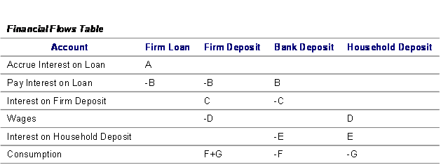

This financial activity allows production to take place:

1. Workers are hired and paid a wage;

2. They produce output in factories at a constant level of productivity;

3. The output is then sold to other firms, banks and households;

4. The price level is set so that in equilibrium the flow of demand equals the flow of output

The graphs below show the outcome of a simulation of this system, which show that a pure credit economy can work: firms can borrow money, make a profit and pay it back, and a single “revolving fund of finance”, as Keynes put it, can maintain a set level of economic activity. [[13]](http://www.debtdeflation.com/blogs/2009/01/31/therovingcavaliersofcredit/#_ftn13)[[4]](#footnote-4)

These stable accounts support a flow of economic activity in time, giving firms, households and banks steady incomes:

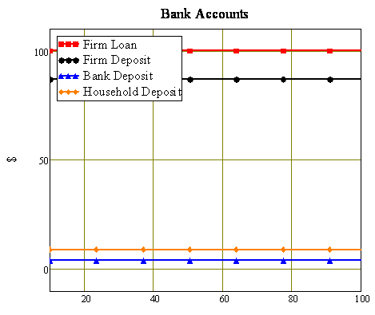

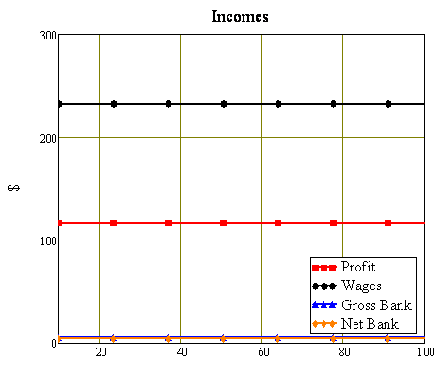

Output and employment also tick over at a constant level:

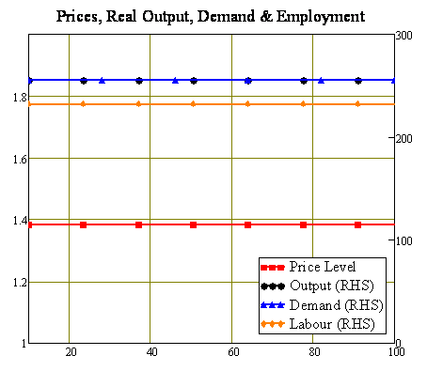

### A More Realistic Toy Pure Credit Economy, and Its Implications

That’s the absolutely basic picture; to get closer to our current reality, a lot more needs to be added. The next model includes, in addition to the basic system shown above:

1. **Repayment of debt**, which involves a transfer from the Firms’ deposit account to an account that wasn’t shown in the previous model that records Banks unlent reserves; this transfer of money has to be acknowledged by the banks by a matching reduction in the recorded level of debt;

2. **Relending** from unlent reserves. This involves a transfer of money, against which an equivalent increase in debt is recorded;

3. The **extension of new loans** to the firm sector by the banks. The firms sector’s deposits are increased, and simultaneously the recorded level of debt is increased by the same amount.

4. **Investment** of part of bank profits by a transfer **from the banking sector’s deposit accounts** to the unlent reserves.

5. **Variable wages, growing labour productivity and a growing population**.

The financial table for *this* system is:

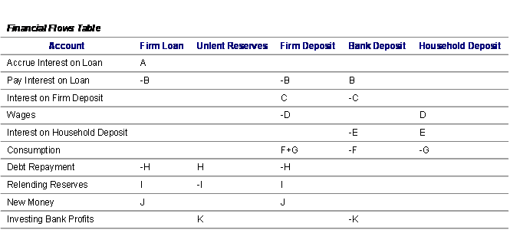

As with the previous model, this toy economy “works”—it is possible for firms to borrow money, make a profit, and repay their debt.

With the additional elements of debt repayment and the creation of new money, this model also lets us see what happens to bank income when these parameters change.

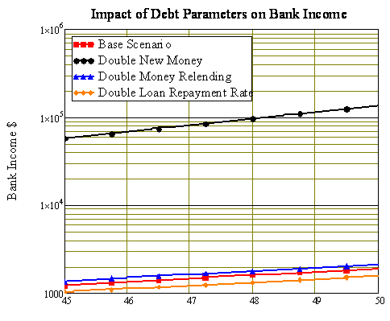

Though in some ways the answers are obvious, it lets us see why banks are truly cavalier with credit. The conclusions are that bank income is bigger:

* If the rate of money creation is higher (this is by far the most important factor);
* If the rate of circulation of unlent reserves is higher; and
* If the rate of debt repayment is lower—which is why, in “normal” financial circumstances, banks are quite happy not to have debt repaid.

In some ways these conclusions are unremarkable: banks make money by extending debt, and the more they create, the more they are likely to earn. But this is a revolutionary conclusion when compared to standard thinking about banks and debt, because the money multiplier model implies that, whatever banks might want to do, they are constrained from so doing by a money creation process that they do not control.

However, in the real world, they *do* control the creation of credit. Given their proclivity to lend as much as is possible, the only real constraint on bank lending is the public’s willingness to go into debt. In the model economy shown here, that willingness directly relates to the perceived possibilities for profitable investment—and since these are limited, so also is the uptake of debt.

But in the real world—and in [my models of Minsky’s Financial Instability Hypothesis](http://www.debtdeflation.com/blogs/wp-content/uploads/2007/04/JPKE1995PageImage9509152794.pdf)—there is an additional reason why the public will take on debt: **the perception of possibilities for private gain from leveraged speculation on asset prices.**

That clearly is what has happened in the world’s recent economic history, as it happened previously in the runup to the Great Depression and numerous financial crises beforehand. In its aftermath, we are now experiencing a “credit crunch”—a sudden reversal with the cavaliers going from being willing to lend to virtually anyone with a pulse, to refusing credit even to those with solid financial histories.

I introduce a “credit crunch” into this model by changing those same key key financial parameters at the 30 year mark, but decreasing them rather than increasing them. Firms go from having a 20 year horizon for debt repayment to a 6.4 year horizon, banks go from increasing the money supply at 10% per annum to 3.2% per annum, while the rate of circulation of unlent reserves drops by 68%.

There is much more to our current crisis than this—in particular, this model omits “Ponzi lending” that finances gambling on asset prices rather than productive investment, and the resulting accumulation of debt compared to GDP—but this level of change in financial parameters alone is sufficient to cause a simulated crisis equivalent to the Great Depression. Its behaviour reproduces much of what we’re witnessing now: there is a sudden blowout [increase] in unlent reserves, and a decline in the nominal level of debt and in the amount of money circulating in the economy.

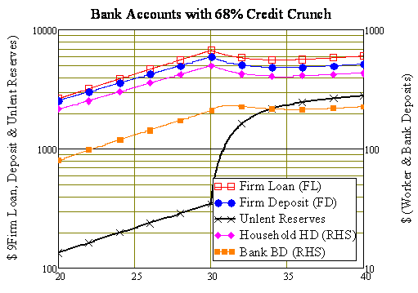

This is the real world phenomenon that Bernanke is now railing against with his increases in Base Money, and already the widespread lament amongst policy makers is that banks are not lending out this additional money, but simply building up their reserves.

Tough: in a credit economy, that’s what banks do after a financial crisis—it’s what they did during the Great Depression. This credit-economy phenomenon is the real reason that the money supply dropped during the Depression: it wasn’t due to “bad Federal Reserve policy” as Bernanke himself has opined, but due to the fact that we live in a credit money world, and not the fiat money figment of neoclassical imagination.

The impact of the simulated credit crunch on my toy economy’s real variables is similar to that of the Great Depression: real output slumps severely, as does employment.

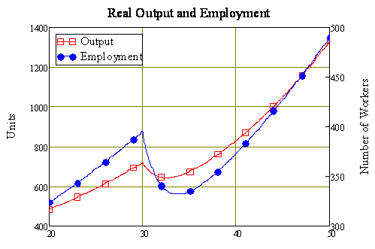

The nominal value of output also falls, because prices also fall along with real output.

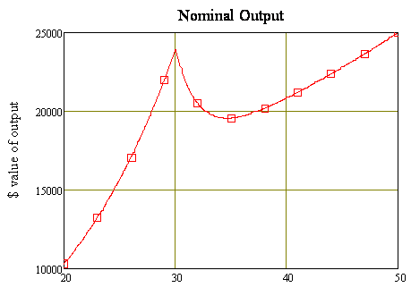

This fall in prices is driven by a switch from a regime of growing demand to one of shrinking demand. Rather than there being a continuous slight imbalance in demand’s favour, the imbalance shifts in favour of supply—and prices continue falling even though output eventually starts to rise.

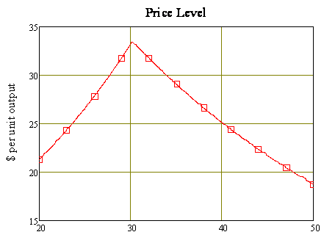

The unemployment rate explodes rapidly from full employment to 25 percent of the workforce being out of a job—and then begins a slow recovery.

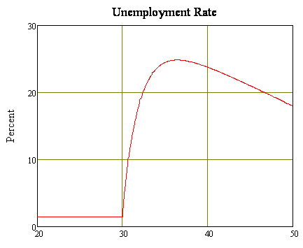

Finally, wages behave in a perverse fashion, just as Keynes argued during the Great Depression: nominal wages fall, but real wages rise because the fall in prices outruns the fall in wages.

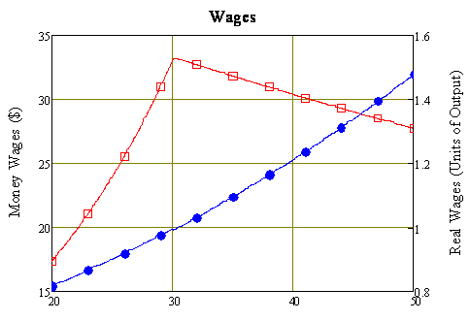

This combination of falling prices and falling output means that despite the fall in nominal debts, the ratio of debt to nominal output actually rises—again, as happened for the first few years of the Great Depression.

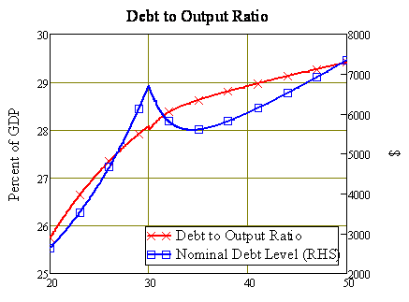

Though this model is still simple compared to the economy in which we live, it’s a lot closer to our actual economy than the models developed by conventional “neoclassical” economists, which ignore money and debt, and presume that the economy will always converge to a “NAIRU”[[14]](http://www.debtdeflation.com/blogs/2009/01/31/therovingcavaliersofcredit/#_ftn14) equilibrium after any shock.

It also shows the importance of the nominal money stock, something that neoclassical economists completely ignore. To quote Milton Friedman on this point:

“*It is a commonplace of monetary theory that nothing is so unimportant as the quantity of money expressed in terms of the nominal monetary unit—dollars, or pounds, or pesos… Let the number of dollars in existence be multiplied by 100; that, too, will have no other essential effect, provided that all other nominal magnitudes (prices of goods and services, and quantities of other assets and liabilities that are expressed in nominal terms) are also multiplied by 100.*” [[15]](http://www.debtdeflation.com/blogs/2009/01/31/therovingcavaliersofcredit/#_ftn15)

The madness in Friedman’s argument is the assumption that increasing the money supply by a factor of 100 will also cause “all other nominal magnitudes” including commodity prices **and debts** to be multiplied by the same factor.

Whatever might be the impact on prices of increasing the money supply by a factor of 100, the nominal value of debt would remain constant: debt contracts don’t give banks the right to increase your outstanding level of debt just because prices have changed. Movements in the nominal prices of goods and services aren’t perfectly mirrored by changes in the level of nominal debts, and this is why nominal magnitudes can’t be ignored.

In this model I have developed, money and its rate of circulation matter because they determine the level of nominal and real demand. It is a “New Monetarism” model, in which money is crucial.

Ironically, Milton Friedman argued that money was crucial in his interpretation of the Great Depression—that the failure of the Federal Reserve to sufficiently increase the money supply allowed deflation to occur. But he [used?] a trivial “helicopter” model of money creation that saw all money as originating from the operations of the Federal Reserve:

“*Let us suppose now that one day a helicopter flies over this community and drops an additional $1,000 in bills from the sky, which is, of course, hastily collected by members of the community. Let us suppose further that everyone is convinced that this is a unique event which will never be repeated…*[*[16]*](http://www.debtdeflation.com/blogs/2009/01/31/therovingcavaliersofcredit/#_ftn16)

*When the helicopter starts dropping money in a steady stream— or, more generally, when the quantity of money starts unexpectedly to rise more rapidly— it takes time for people to catch on to what is happening. Initially, they let actual balances exceed long— run desired balances…*” (p. 13)

and [he used] a trivial model of the real economy that argued that it always tended back to equilibrium:

“*Let us start with a stationary society in which … (5) The society, though stationary, is not static. Aggregates are constant, but individuals are subject to uncertainty and change. Even the aggregates may change in a stochastic way, provided the mean values do not… Let us suppose that these conditions have been in existence long enough for the society to have reached a state of equilibrium…” (pp. 2-3)*

One natural question to ask about this final situation is, *“ What raises the price level, if at all points markets are cleared and real magnitudes are stable?”* The answer is, *“ Because everyone confidently* ***anticipates*** *that prices will rise.*” (p. 10)

Using this simplistic analysis, Milton Friedman claimed that inflation was caused by “too many helicopters” and deflation by “too few”, and that the deflation that amplified the downturn in the 1930s could have been prevented if only the Fed had sent more helicopters into the fray:

“*different and feasible actions by the monetary authorities could have prevented the decline in the money stock—indeed, produced almost any desired increase in the money stock. The same actions would also have eased the banking difficulties appreciably. Prevention or moderation of the decline in the stock of money, let alone the substitution of monetary expansion, would have reduced the contraction’s severity and almost as certainly its duration.*” [[17]](http://www.debtdeflation.com/blogs/2009/01/31/therovingcavaliersofcredit/#_ftn17)

With a sensible model of how money is endogenously created by the financial system, it is possible to [a] concur that a decline in money contributed to the severity of the Great Depression, but [b] not to blame that on the Federal Reserve not properly exercising its **effectively impotent** powers of fiat money creation. Instead, the decline was due to the normal operations of a credit money system during a financial crisis that its own reckless lending has caused—the Cavaliers are cowards who rush into a battle they are winning, and retreat at haste in defeat.

However, with his belief in Friedman’s analysis, Bernanke did blame his 1930 predecessors for causing the Great Depression. In his paean to Milton Friedman on the occasion of his 90th birthday, Bernanke made the following remark:

“*Let me end my talk by abusing slightly my status as an official representative of the Federal Reserve. I would like to say to Milton and Anna: Regarding the Great Depression. You’re right, we did it. We’re very sorry. But thanks to you, we won’t do it again.*” [[18]](http://www.debtdeflation.com/blogs/2009/01/31/therovingcavaliersofcredit/#_ftn18)

In fact, thanks to Milton Friedman and neoclassical economics in general, the Fed ignored the run up of debt that has caused this crisis, and every rescue engineered by the Fed simply increased the height of the precipice from which the eventual fall into Depression [!] would occur.

Having failed to understand the mechanism of money creation in a credit money world, and failed to understand how that mechanism goes into reverse during a financial crisis, neoclassical economics may end up doing what by accident what Marx failed to achieve by deliberate action, and bring capitalism to its knees.

## Conclusion

**Neoclassical economics—and especially that derived from Milton Friedman’s pen—is mad, bad, and dangerous to know.** [And furthermore, neoclassical economics is about all you have been able to find at your Yales and your Harvards. Ref: [How the Fed bought the Economics Profession](http://chasegalleryconnect.org/FNC_C/Data/Personal%20Finance,%20Investing,%20Estates,%20Retirement/MacroEconomics/Money/Monetary%20Reform/20090907%20How%20the%20Fed%20bought%20the%20Economics%20Profession.html) -FNC]

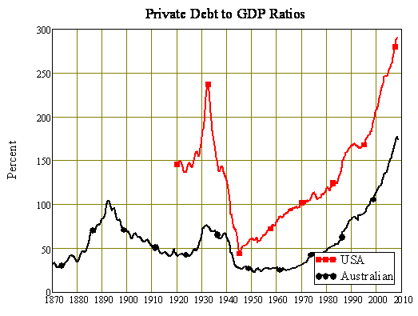

## Debtwatch Statistics February 2009

[This final section of Keen’s paper appears to be separate from its basic content. It is retained below only to preserve the 1-1 correspondence between the basis for my comments and the Keen original. –FNC]

My discussion of the most recent monthly data is abbreviated given the length of this Report, but it now appears that the debt bubble has started to burst. Private debt fell by $A$5 billion in the last month, the first fall since 2003, and the steepest monthly fall on record.

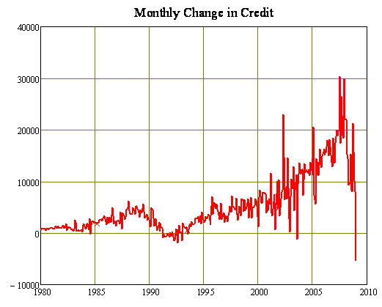

As a result, Australia’s Debt to GDP ratio has started to fall.

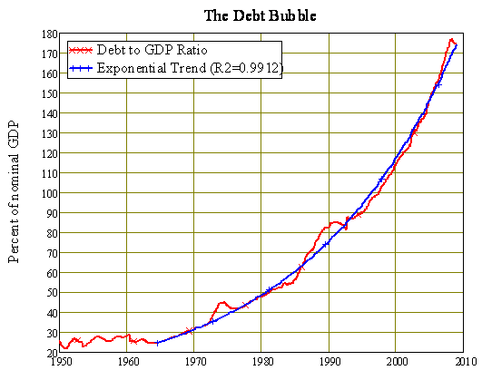

However, it might rise once more if deflation takes hold. This was the Depression experience when the debt to GDP ratio rose even as nominal debt levels fell. Leaving that possibility aside for the moment, it appears that Australia’s peak private debt to GDP ratio occurred in March 2008, with a ratio of 177% of GDP including business securities (or 165% excluding business securities).

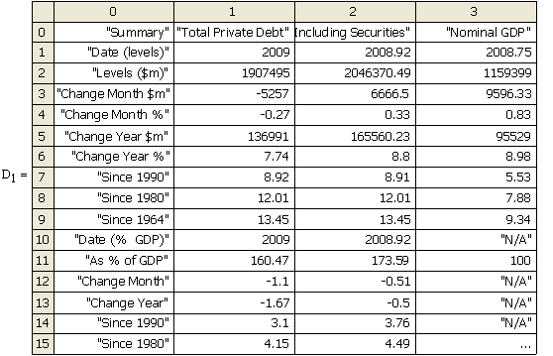

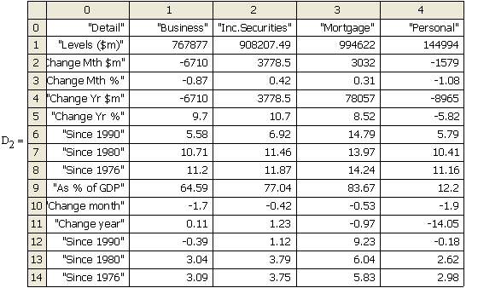

## References

[1] Marx, Capital Volume III, Chapter 33, The medium of circulation in the credit system, pp. 544-45 [Progress Press]. <http://www.marx.org/archive/marx/works/1894-c3/ch33.htm>. Emphases added.

[2] Notably the “labour theory of value”, which argues erroneously that all profit comes from labour, the notion that the rate of profit has a tendency to fall, and the alleged inevitability of the demise of capitalism; see [my papers](http://www.debtdeflation.com/blogs/research/) on these issues on the Research page of my blog under Marx.

[3] Kydland & Prescott, [Business Cycles: Real Facts and a Monetary Myth](http://www.minneapolisfed.org/publications_papers/pub_display.cfm?id=225), Federal Reserve Bank of Minneapolis Quarterly Review, Spring 1990.

[4] “The Endogenous Money Stock”, Journal of Post Keynesian Economics, 1979, Volume 2, pp. 49-70.

[5] Basil Moore 1983, “Unpacking the post Keynesian black box: bank lending and the money supply”, Journal of Post Keynesian Economics 1983, Vol. 4 pp. 537-556; here Moore was quoting a Federal Reserve economist from a 1969 conference in which the endogeneity of the money supply was being debated.

[6] This policy “worked” in the sense that Central Banks were successful in controlling short run interest rates, and appeared to work in controlling inflation; but it is now becoming obvious that its success on the latter front was a coincidence—the era of low inflation coincided with the dramatic impact of China and offshore manufacturing in general on consumer and producer prices—and it led to Central Banks completely ignoring the debt bubble that has caused the global financial crisis. As a result, interest rate targetting is also going the way of the Dodo now.

[7] see Table 10 in Yueh-Yun C. OBrien, 2007. “[Reserve Requirement Systems in OECD Countries](http://www.federalreserve.gov/pubs/feds/2007/200754/index.html)” , Finance and Economics Discussion Series, Divisions of Research & Statistics and Monetary A¤airs, Federal Reserve Board, 2007-54, Washington, D.C;. The US rule implies that the main reason for the “reserve requirement” these days is to meet household demand for cash.

[8] Bernanke 2002: Remarks by Governor Ben S. Bernanke Before the National Economists Club, Washington, D.C., November 21, 2002. [Deflation: Making Sure “It” Doesn’t Happen Here](http://www.federalreserve.gov/boarddocs/speeches/2002/20021121/default.htm). Emphasis added.

[9] “[Microsoft resorts to first layoffs, cutting 5,000](http://finance.yahoo.com/news/Microsoft-resorts-to-first-apf-14127574.html)“, Yahoo Finance January 22nd 2009.

[10] And, for that matter, by Austrian economics, whose analysis of money is surprisingly simplistic. Though Austrians advocate a private money system in which banks would issue their own currency, they assume that under the current money system, all money is generated by fractional reserve lending on top of fiat money creation. This is strange, since if they advocate a private money system, they need a model of how banks could create money without fractional reserve lending. But they don’t have one.

[11] Graziani A. (1989). The Theory of the Monetary Circuit, Thames Papers in Political Economy, Sprin, pp.:1-26. Reprinted in M. Musella and C. Panico (eds) (1995). The Money Supply in the Economic Process, Edward Elgar, Aldershot.

[12] Keynes 1937, “ Alternative theories of the rate of interest” , Economic Journal, Vol. 47, pp. 241-252: p. 247

[13] The parameters were an initial loan of $100, loan rate of interest of 5%, deposit rate of 1%, 3 month lag between financing production and receiving the sales proceeds, 1/3rd of the surplus from production going to firms as profits and the remainder to workers as wages, a one year lag in price adjustments, a money wage of $1, worker productivity of 1.1 units of physical output per worker per year, and a one year lag in spending by bankers and a two week lag by workers.

[14] “Non-Accelerating Inflation Rate of Unemployment”, another one of Milton’s mythical constants.

[15] Milton Friedman 1969, “The Optimal Quantity of Money”, in The Optimal Quantity of Money and Other Essays, Macmillan, Chicago, p. 1.

[16] Milton Friedman 1969, pp. 5-6

[17] Milton Friedman and Anna Schwartz 1963, A Monetary History of the United States 1867-1960, Princeton University Press, Princeton, p. 301.

[18] Remarks by Governor Ben S. Bernanke At the Conference to Honor Milton Friedman, University of Chicago, Chicago, Illinois November 8, 2002 [On Milton Friedman’s Ninetieth Birthday](http://www.federalreserve.gov/boarddocs/speeches/2002/20021108/default.htm).

## Responses (309 of them)

[If you look at all at the responses (not included here), I suggest searching for “Steve Keen” then working back up as needed to see what he’s commenting about. –FNC]

1. [2] Notably the “labour theory of value”, which argues erroneously that all profit comes from labour, the notion that the rate of profit has a tendency to fall, and the alleged inevitability of the demise of capitalism; see my papers on these issues on the Research page of my blog under Marx. [↑](#footnote-ref-1)
2. [6] This policy “worked” in the sense that Central Banks were successful in controlling short run interest rates, and appeared to work in controlling inflation; but it is now becoming obvious that its success on the latter front was a coincidence—the era of low inflation coincided with the dramatic impact of China and offshore manufacturing in general on consumer and producer prices—and it led to Central Banks completely ignoring the debt bubble that has caused the global financial crisis. As a result, interest rate targetting is also going the way of the Dodo now. [↑](#footnote-ref-2)
3. [10] And, for that matter, by Austrian economics, whose analysis of money is surprisingly simplistic. Though Austrians advocate a private money system in which banks would issue their own currency, they assume that under the current money system, all money is generated by fractional reserve lending on top of fiat money creation. This is strange, since if they advocate a private money system, they need a model of how banks could create money without fractional reserve lending. But they don’t have one. [↑](#footnote-ref-3)
4. [13] The parameters were an initial loan of $100, loan rate of interest of 5%, deposit rate of 1%, 3 month lag between financing production and receiving the sales proceeds, 1/3rd of the surplus from production going to firms as profits and the remainder to workers as wages, a one year lag in price adjustments, a money wage of $1, worker productivity of 1.1 units of physical output per worker per year, and a one year lag in spending by bankers and a two week lag by workers. [↑](#footnote-ref-4)